1. https://ide.hpccsystems.com/workspaces/share/1aacf18b-77f4-44e6-854d-8539b60b4f85
2. Register for a Cloud IDE account

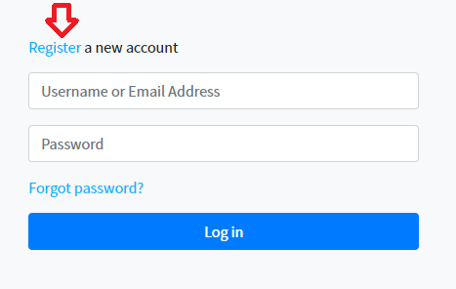

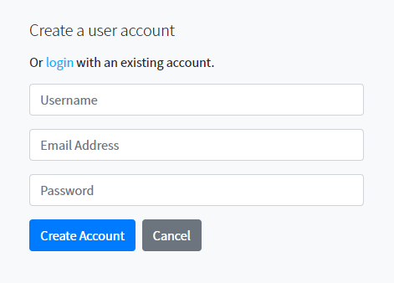

1. Once the account is successfully created, you will be automatically logged into the Cloud IDE application.
2. Please select the workspace from the drop down.

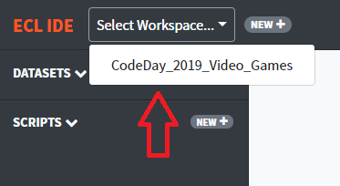

1. The datasets and scripts available in the workspace will be loaded. Click on each datasets and scripts to see the content

